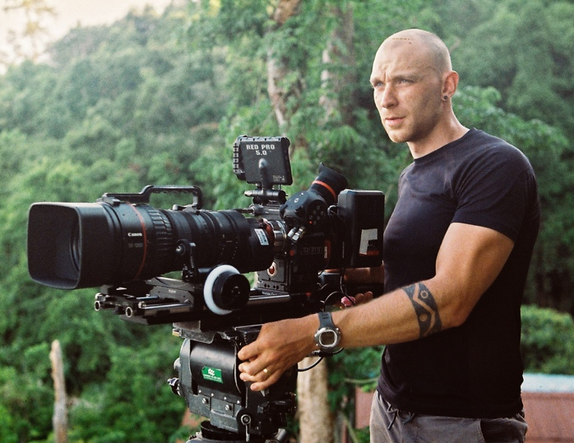
Will Foster-Grundy
Based in Borneo
Email: willfostergrundyfilm@gmail.com
Website: www.willfostergrundy.com

Will is an English cinematographer and producer operating across genres and working environments. Just as comfortable on set as underwater, up a mountain, or shooting from the roof of a moving vehicle. Will strives to create powerful, emotive imagery in the most challenging of situations. Will has provided cinematography for a number of independent productions selected for international film festivals between working for broadcast clients including Apple TV, BBC, Netflix and Disney+.

Watch Will’s Showreel

Select Credits
DoP/Producer/Director – Felines (unreleased) | Ind. / Terra Mater
Feature length documentary detailing mankind’s relationship with big cat species in the modern day. A mix of investigative filmmaking, re-enactments, cinema verité and natural history. Shoots across four continents over 12 months.

Cinematographer – A Real Bug’s Life (unreleased) | Plimsoll Productions / Disney+
DoP for two Borneo-based wide-angle macro sequences involving shooting human contributors and natural history behaviour. Both involved the use of macro motion control rigs and artificial lighting to mimic daylight and twilight conditions.

Cinematographer – Titan (unreleased) | Plimsoll Productions / AppleTV
DoP for two Borneo-based sequences both requiring extensive grip and motion control work including stabilised long lens rigs from boats and 4x4’s as well as gimbal, slider and jib/crane operation to capture behaviour in the wild.

Cinematographer – Islands (unreleased) | Wall to Wall (Warner Bros.) / Discovery
Principal DoP for the majority of sequences within the Borneo episode of this six-part series. Involving expedition filmmaking, motion-controlled time lapse work, cable dolly and tree platform upper forest canopy capture, as well as gyro-stabilised shooting from riverboats.

Cinematographer – Planet Earth III (unreleased) | BBC NHU / BBC
DoP for a forest-based sequence involving high speed behavioural capture as well as new, innovative camera techniques to achieve never-before-seen footage.

Cinematographer – The Earthshot Prize (2021) | Silverback Studios / BBC
DoP for a controlled cinematic sequence documenting an orangutan researcher. Required multiple camera operation, motion control including heavy-payload gimbal and harness work, long lens and macro slider operation, as well as interior and exterior lighting. Some specific editorial requests to assist with match-cutting across UK-based sequences.

Cinematographer – Animal (2022) | Plimsoll Productions / Netflix
DoP for two Borneo-based natural history sequences, both requiring extensive use of motion control (30ft crane/jib, slider, Ronin-2, cable dolly) and long lens work from forest canopy platforms at over 50m.

Cinematographer – Eden: Untamed Planet (2021) | BBC Studios Natural History Unit
Cameraman for multiple Borneo-based sequences, covering natural history, and documenting a scientific operation in remote primary rainforest.

DoP/Director/Producer– Pythons and the Exotic Pet Trade (2021) | Ind. / Off the Fence
Feature-length investigative documentary into the international trade and breeding of ball pythons for pets worldwide. Involved undercover work and investigative journalism across 4 continents.

DoP/Co-Director/Producer – Eyes of the Orangutan (2021) | Ind. / Terra Mater
Feature length documentary uncovering the truth about the sourcing of wild orangutans for their use in the wildlife tourism industry. Involved covert filming, re-enactment scenes, undercover investigations and shooting in remote locations across Southeast Asia. Nominated at Wildscreen 2022 and Jackson Wild 2022.

Cameraman – Corona - The Pandemic and the Pangolin (2020) | Terra Mater
Contributed additional photography from animal markets in Benin and Indonesia for this feature length documentary. Recent winner at Jackson Wild 2020.

DoP/Director/Producer – Otters and the Exotic Pet Trade (2019) | Ind. / Off the Fence
Investigative documentary into the illegal pet trade of otters worldwide. Involved undercover work and investigative journalism across 3 countries. Recent winner at Wildlife Conservation Film Festival 2019.

DoP/Director/Producer – Timor-Leste from Below (2018) | SZtv
10-part web series filming marine stories from Timor-Leste. Will wrote, directed, produced, filmed topside and underwater, and recorded sound in incredibly remote locations for this series with a small crew. Production involved running a scuba diving expedition to an un-dived region of Timor-Leste and freediving with cetaceans including blue and sperm whales. Will also worked as DIT and colourist.

Director of Photography – Sun Bears: Return to the Wild (2018) | SZtv
A short film documenting the release of two rehabilitated Bornean sun bears back into the heart of the rainforest. Will was the DoP on this production which involved taking a helicopter into primary rainforest and capturing the moment two sun bears were released back to the jungle.

Cameraman/Timelapse – Mysteries of the Mekong (2018) | Smithsonian Earth/Love Nature
For this international broadcast production Will completed six weeks of filming across the wilder parts of Cambodia and Laos, contributing time-lapse photography, slider and gimbal camerawork, and a handful of natural history sequences to two episodes of the series. Production involved staying in remote jungle camps, constructing and filming from hides, long days spent tracking primates, and two weeks filming inside cave systems. Will also worked as DIT.

Certifications
Divemaster
PADI License 356028 | March 2014 - Present

Education
Durham University
Bachelor of Science (BSc) Hons, Zoology/Animal Biology, Grade: 2:1, 2010 – 2013

Languages
Basic Bahasa Malaysia
Currently studying Chinese Mandarin

